Chapter 3 Radioactivity and radiation
Chapter Test Total marks 45

Name: Class: Date:
Section A (1 mark per question)
Select the best answer for each question.
Question 1
Beta-minus radiation is:
- energy emitted from an electron of an atom
- an electron ejected from an atom
- a helium nucleus emitted from an atom
- an electron emitted from the nucleus of an atom

Question 2
Which of the following travels at the greatest speed?
- gamma radiation
- beta radiation
- alpha radiation
- They all have the same speed.

Question 3
The heaviest form of radiation is:
- gamma
- beta-minus
- alpha
- none of the above

Question 4
The type of radiation that is most ionising is:
- gamma
- beta
- alpha
- none of the above

Question 5
The most penetrating form of radiation is:
- gamma
- beta
- alpha
- none of the above
Question 6
The type of radiation we are exposed to from the Sun is:
- gamma
- beta
- alpha
- none of the above

Question 7
The value of x in the decay equation: is:
- 238
- 236
- 234
- 232

Questions 8 and 9 refer to the following information.
Strontium-90 is one of the radioisotopes that was released during the Fukushima nuclear disaster in Japan. Strontium-90 has a half-life of 28.8 years.
Question 8
How many neutrons are there in each nucleus of Sr-90?
- 90
- 38
- 128
- 52

Question 9
If 1.8 × 10¹⁰ atoms of Sr-90 were released during the accident, how many of the original Sr-90 nuclides will still be in existence in 144 years?
- none
- 3.6 × 10⁹
- 2.8 × 10⁸
- 5.6 × 10⁸

Question 10
A radioactive sample of oxygen-15 has a half-life of 110 minutes. If the amount remaining after 5.5 h is 0.80 g, the original sample had a mass of:
- 2.4 g
- 2.8 g
- 6.4 g
- 9.6 g

Section B
Question 1
Complete the following decay equations by replacing :

a. (1 mark)

b. (1 mark)

c. (1 mark)

Question 2
When bombarded with neutrons, gold (Au-197) undergoes neutron absorption to become the radioactive isotope gold-198. Given that gold has an atomic number of 79, write a balanced equation for:
a. the absorption of a neutron by a gold-197 atom (2 marks)

b. the beta decay of a radioactive nucleus of gold-198. (2 marks)

Question 3
Cobalt-60 has a half-life of 5.3 years. A sample of pure cobalt-60 has a mass of 50 µg. How much of the Co-60 remains after:
a. 10.6 years? (2 marks)

b. 15.9 years? (2 marks)

c. 21.2 years? (3 marks)

Question 4
Why is alpha radiation not used as a source in external radiotherapy treatment? (2 marks)

Question 5
A 78 kg man is exposed to 200 mJ of gamma radiation. Calculate:
a. his absorbed dose (1 mark)

b. his dose equivalent (1 mark)

c. his dose equivalent if he had been exposed to 200 mJ of alpha radiation instead (1 mark)

d. the energy of the radiation in electronvolts (eV). (1 mark)

Question 6
As a doctor you prescribe a course of radiotherapy for a patient with breast cancer. The procedure involves inserting a radioactive source into the affected region. Explain which type of radiation source—alpha, beta-minus or gamma—you would prefer to use and why. (4 marks)

Question 7
A scientist uses a Geiger counter to measure the radiation of a radioactive sample. She records the count as 60 000 emissions per minute.
a. Calculate the activity of the sample in becquerel (Bq). (1 mark)

b. It takes 1.5 hours for a 100 µg sample of the radioisotope to decay to 25 µg.
Calculate the half-life of the sample in minutes. (3 marks)

Question 8
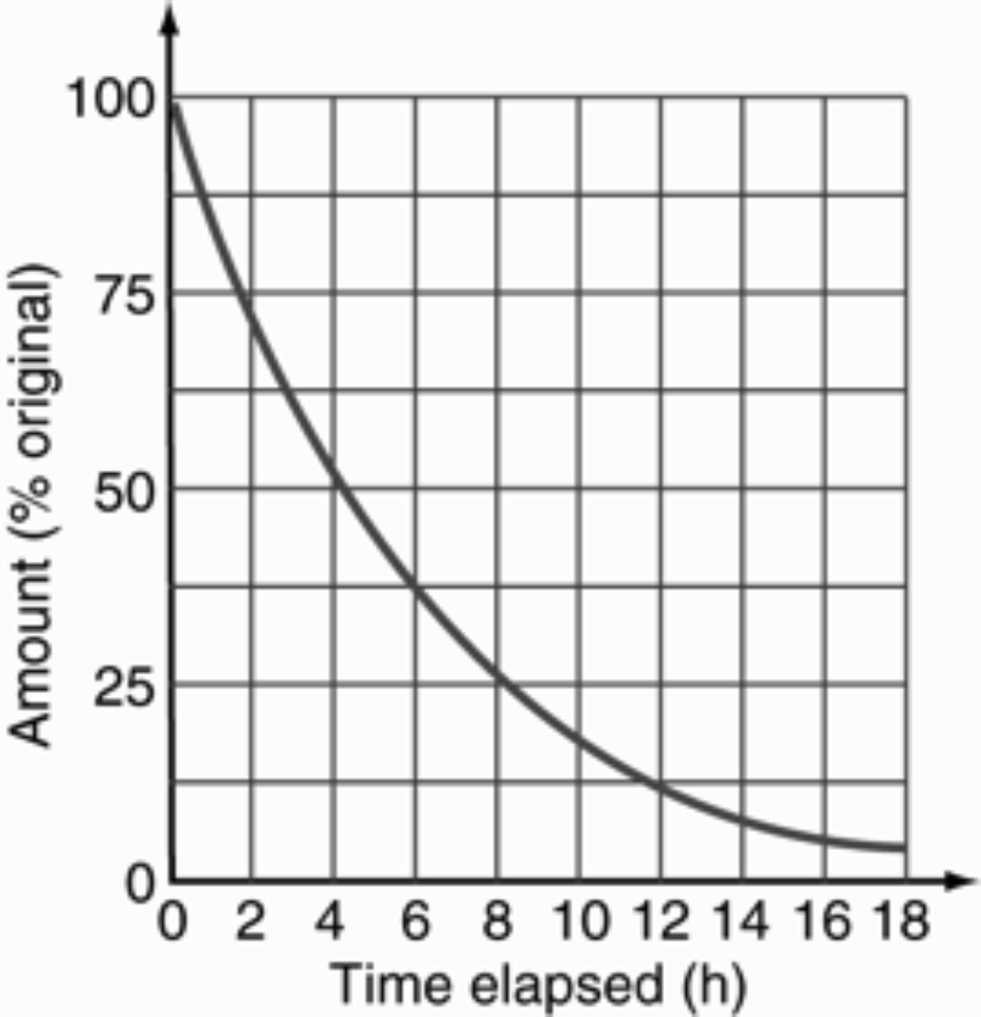
The radioactive decay of a particular isotope is shown on the graph below. The initial mass of the radioisotope is 20 g.

a. Find the time it takes for a 20 g sample to decay to 5.0 g. (2 marks)

b. Find the half-life of the sample. (1 marks)

c. How much of the original radioisotope (in grams) remains after 6.0 hours? (2 marks)

d. Calculate the amount of the radioisotope remaining (in grams) after 20 hours have elapsed.
(2 marks)

